Woollam Waltzing Matilda Outback Art Show 2011
On display 2 May - 24 June 2011
The 2011 Awards Presentation evening was held at the Outback Regional Gallery in Winton on Friday 6 May. The large crowd included Ian MacGregor, representing principal sponsor, Woollam Constructions, and a number of participating artists.

Judge Metka Skrobar from the Gold Coast, noted that the standard and variety of artists' interpretations of the title “ Droughts and Flooding Rains” was very impressive indeed and a delight and feast for not only the eyes of the audience but also a stimulus for their imagination.
Section 2: Three Dimensional Works

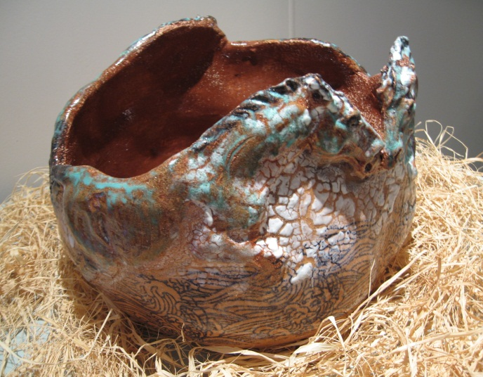 | 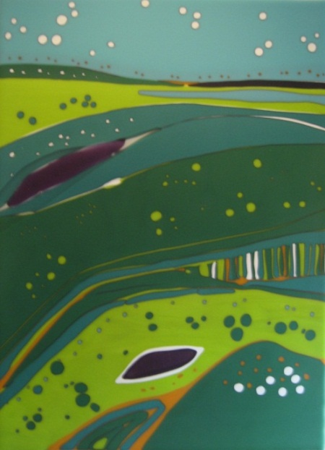
Winner Three dimensional works 2011  The ones that got away 2010 Sue Fraser  ceramic | Second place Three dimensional works 2011  Beyond 2011 Gayle Shaw  fused glass
There was a great diversity of three dimensional entries, with works in ceramics, textiles, metal, wood and glass.

A New South Wales entry, "The ones that got away", received the major award, with the judge describing the work as "..Beautifully constructed piece of sculpture ..The empty brown interior may represent the time of drought and waiting to be filled with rain. The calligraphy patterns in the lower section seem like patterns of the rivers courses in flood.....great movement, colour harmony and texture."

Second placing went to Beyond "...fused glass piece possesses a certain simple design...movement, colour harmony and the patterns of the land in flood ".

Third placing was Catchments "..thought provoking piece of work composed of taps, corrugated iron roof and empty vessels all waiting to be filled. Workmanship is fine, precise, symbolic ..."

First: | The ones that got away | (ceramic) Sue Fraser Alstonville NSW.
Second: | Beyond | (fused glass) Gayle Shaw Graceville Qld.
Third: | Catchments | (mixed clays and porcelain) Megan Puls Nerang Qld
Highly Commended
40 days & 40 nights | (warm glass sculpture) Len Cooper Moorooka Qld

